Block 2 Challenge Proposal

# Purpose

For my challenge, I plan on making a pass-and-play digital version of my kid’s favorite board game, *The Wizard Always Wins.* A demo of how to play this game can be found at <https://www.youtube.com/watch?v=lX_wD7aMKEY>. This is a fairly simple game that my kids love that has several elements that will be well-suited to practicing things we have learned in this course, such as drag-and-drop, arrays, modules, random generation, and managing several different modules.

# Audience

The audience for my application will be my professor for this class who will be grading my assignment as well as my family who will have fun playing this game with a digital interface.

# Data sources

I am not currently aware of a public API that will be helpful for this project, but if I find one, I plan on using it to help implement this game. There is a playing card API that might be useful, but I need to look into if it can be modified to be useful for this game. I also plan on using localStorage to help manage memory from turn to turn, and I’m guessing I will need to use some kind of local JSON file to help keep track of all the pieces of the game.

# Initial Module list

I currently predict needing modules or classes for the following categories: Game Board, Element Cards, Characters, Level Dials, Gem Tokens, Element Tokens, and the Draw Bag. I will also need code to manage the gameplay.

# Wireframes for each view of your application

Game Parts:

* 60 Element Cards
  + 9 two plant cards
  + 3 three plant cards
  + 9 two snail cards
  + 3 three snail cards
  + 9 two potion bottles cards
  + 3 three potion bottles cards
  + 9 two bones cards
  + 3 three bones cards
  + 9 two mushroom cards
  + 3 three mushroom cards
* 7 Characters
* 5 Level trackers
* 5 Turn markers
* 40 gem tokens (8 of each of 5 colors)
* 25 Element tokens(5 of each element)
* 3 add-a-gem tokens
* 3 Level-Up tokens
* Draw bag
* Game board/turn tracker
* Rule reference cards

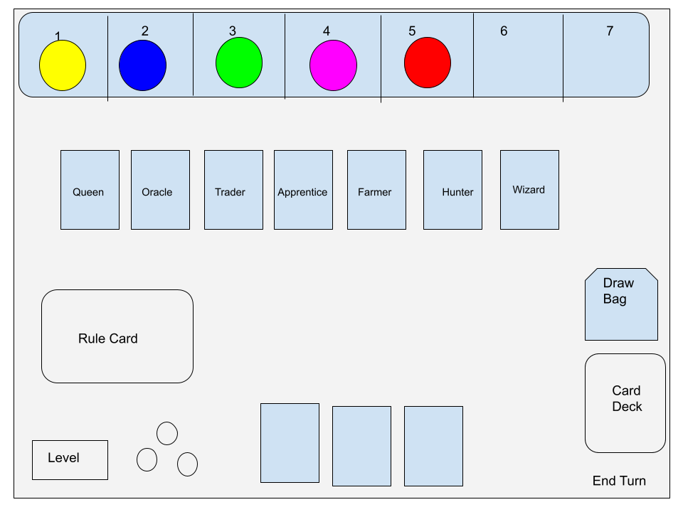

This wireframe shows what a player would see during their turn. It would show the next player’s cards etc for the next turn and reset as needed in-between rounds.

# Colors/Typography/Specific Element styling

I originally plan on making a very stripped-down version of the game styling and upgrading it as time allows. I plan on using small SVG’s for most game art instead of pictures of the actual game pieces. I do plan on keeping most of the same colors from the game, and I plan on using pictures as much as possible so younger players can still participate.

# Schedule

## Week 10

My project goal for this week is to get all game elements on the board in the correct location. All elements should be in existence but not necessarily functioning yet.

## Week 11

My project goal for this week would be to add basic functionality to the elements on the board and work towards making the game playable.

## Week 12

This week I will work on making the game pretty including adding graphics, work on any animations or other movements, and fix any other outstanding functionality issues.

## Week 13

This final week I will work on adding the final touches on the game and fix any unsolved bugs. If time allows, I will work on the stretch goal of having the game enforce its own rules or some of its rules instead of the players needing to be mindful of the rules.